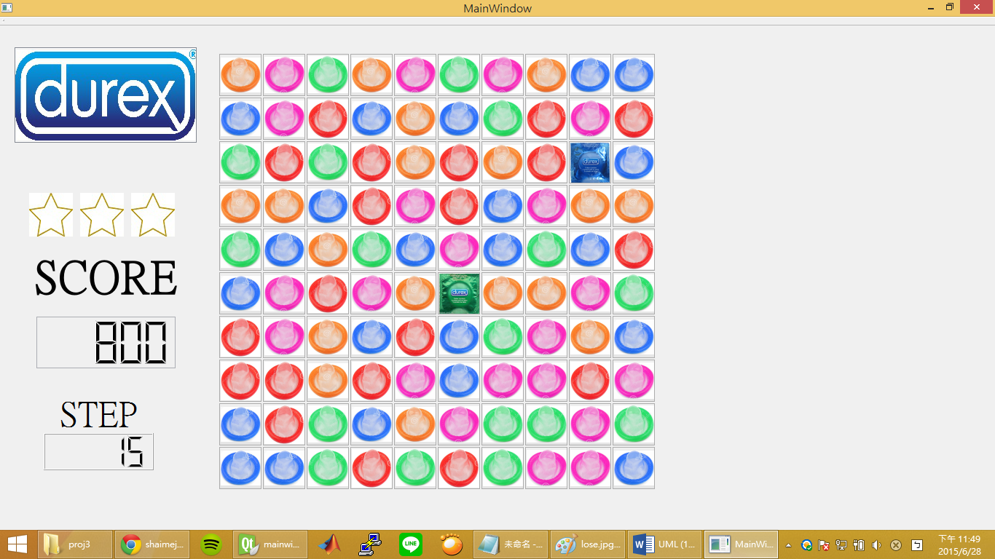

|  |
| --- |
| MainWindow |
| + q[10][10]  +int c[10][10]  +int k[10][10]  +int t  +int score  +int step  +int ii  +int jj  +int mm  +int nn |
| + picture();  + remove();  + click();  + drop();  + special(int,int);  + star(int, int,int,int);  + delay();  + move(in) |